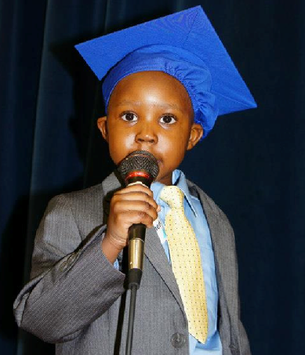
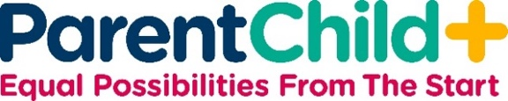

What is the ParentChild+ Program?

ParentChild+ is a free program that partners with families to help young children build the skills they need for school success.

A trained community member will visit your home twice each week to support you in engaging your child in play, conversation, and everyday learning activities that build language, learning, and confidence.

Each week, your family will receive a book or toy to keep you can continue using together between visits.

We support you in strengthening everyday interactions that prepare your child for school by building on your family’s routines, values, language, and cultural strengths.

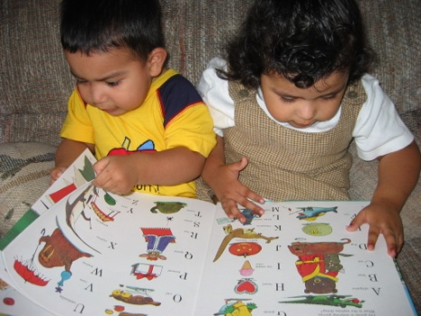

Did You Know….?

You are your child’s first and most important teacher.

Your home is your child’s first classroom.

Children learn best through play, conversation, and shared activities.

Reading and talking with your child in your home language supports school readiness.
What Parents Say About the Program:

“ParentChild+ shows you that no matter what language you speak, you can teach your child how to prepare for school.”

“I learned how to be closer with my child and help her with her learning.”

“ParentChild+ is a great education not only for children, but also for parents!”

“I learned that all children want to learn.”

“No matter where you’re from or what your background is, ParentChild+ helps you prepare your child to succeed in school and in life.”

