For more information, please fill out and return the form and return it to the office or person who provided this brochure.

Child Name: ______________________________________________________________

Child Date of Birth: ________________________________________________________

Parent Name: _____________________________________________________________

Address: __________________________________________________________________

Telephone: ________________________________________________________________

Language(s) Spoken at Home: _____________________________________________

PERSONALIZED CONTACT
INFORMATION PAGE

Your Site/ParentChild+

Personalized Contact Information

Coordinator Name, Title
Address
Telephone Number
email

(INSERT THE LOGO OF YOUR ORGANIZATION)

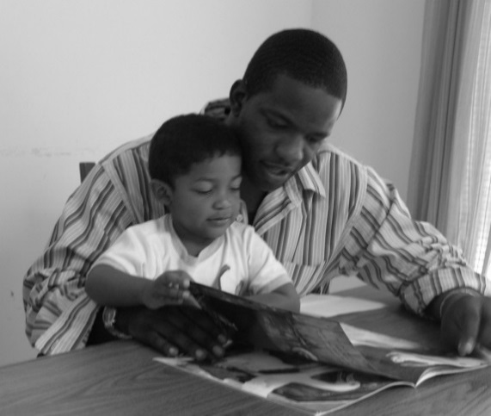



ParentChild+ partners with parents and caregivers and their young children through one-on-one home visits that strengthen caregiver–child interactions, build on family strengths, routines, and culture, and support school readiness.

“Talking, reading, and playing together every day helps children build confidence and a love of learning.”

