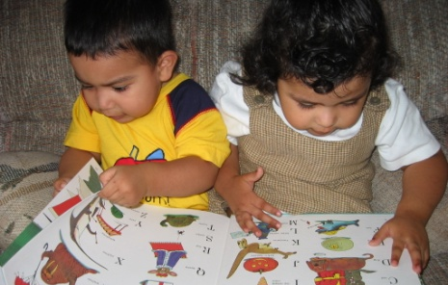

Partnering with Families for Early Learning
If you are the parent or caregiver of a 16- to 30-month-old child and live in _____________________, you may be eligible for ParentChild+, a free program that partners with families to support early learning and school readiness by building on family strengths, culture, and home language.
ParentChild+ provides an Early Learning Specialist who will visit your home twice each week and work alongside you to support learning through play, conversation, and everyday family routines. Your family will also receive free educational books and toys to keep, providing additional opportunities for shared learning between visits.
There is no cost to participate.
Fill out the form below to receive more information. Return it to the agency that provided this form or to the ParentChild+ office listed below.
You may also call the Program Coordinator at this phone number: __________________

(Please return the bottom part of the form)
Parent Name(s): _________________________________________________________________
Street Address: __________________________________________________________________
Phone Number: _________________________________________________________________
Child’s Name: ____________________________________________________________________
Child’s Date of Birth: _____________________________________________________________
Language(s) Spoken at Home: ___________________________________________________

